**Linux Assignment - Commands**

**Curl -s** command -> used to download and upload data via http requests.

-s Turn on the silent mode, it mutes curl.

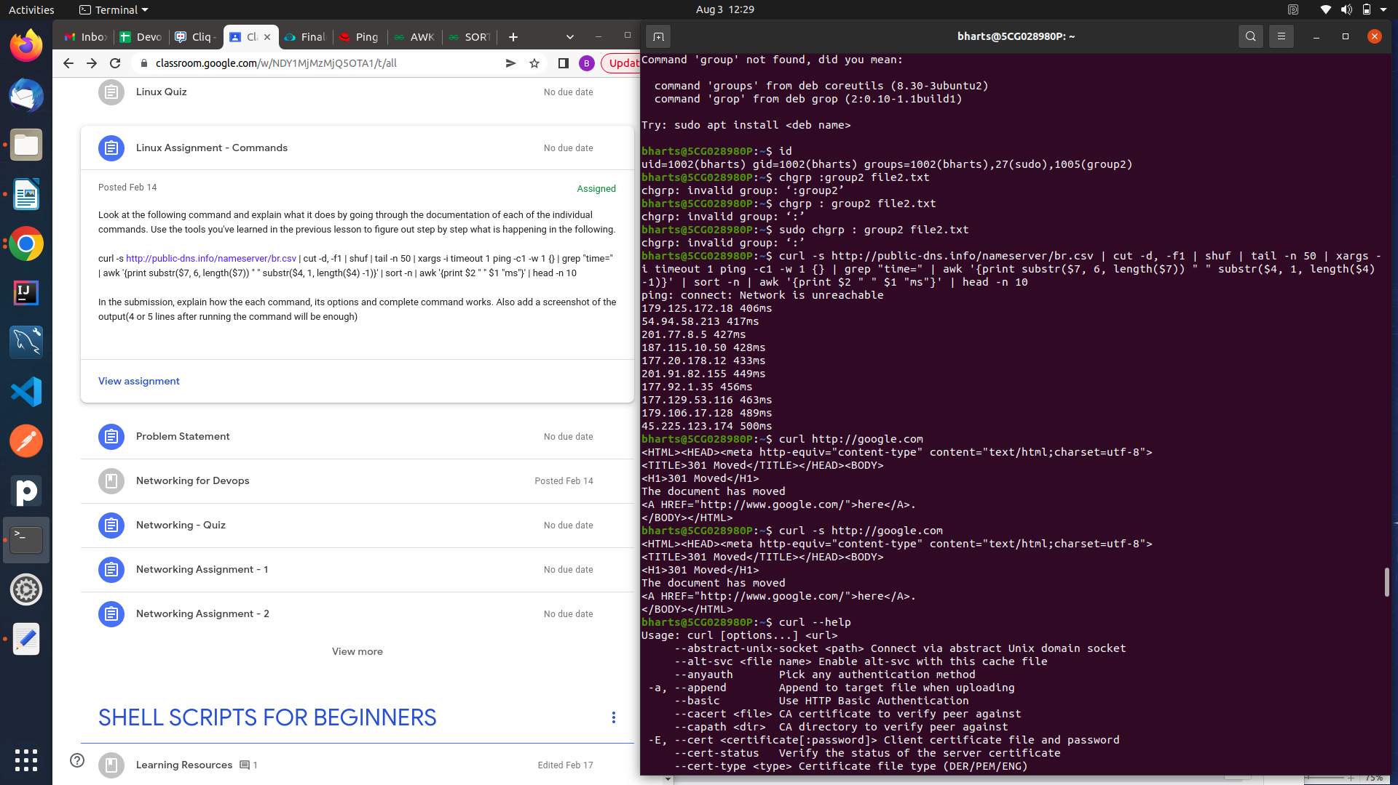

**cut -d, -f1** -> it divides the output and it shows the ist field of each line from the file till , delimiter

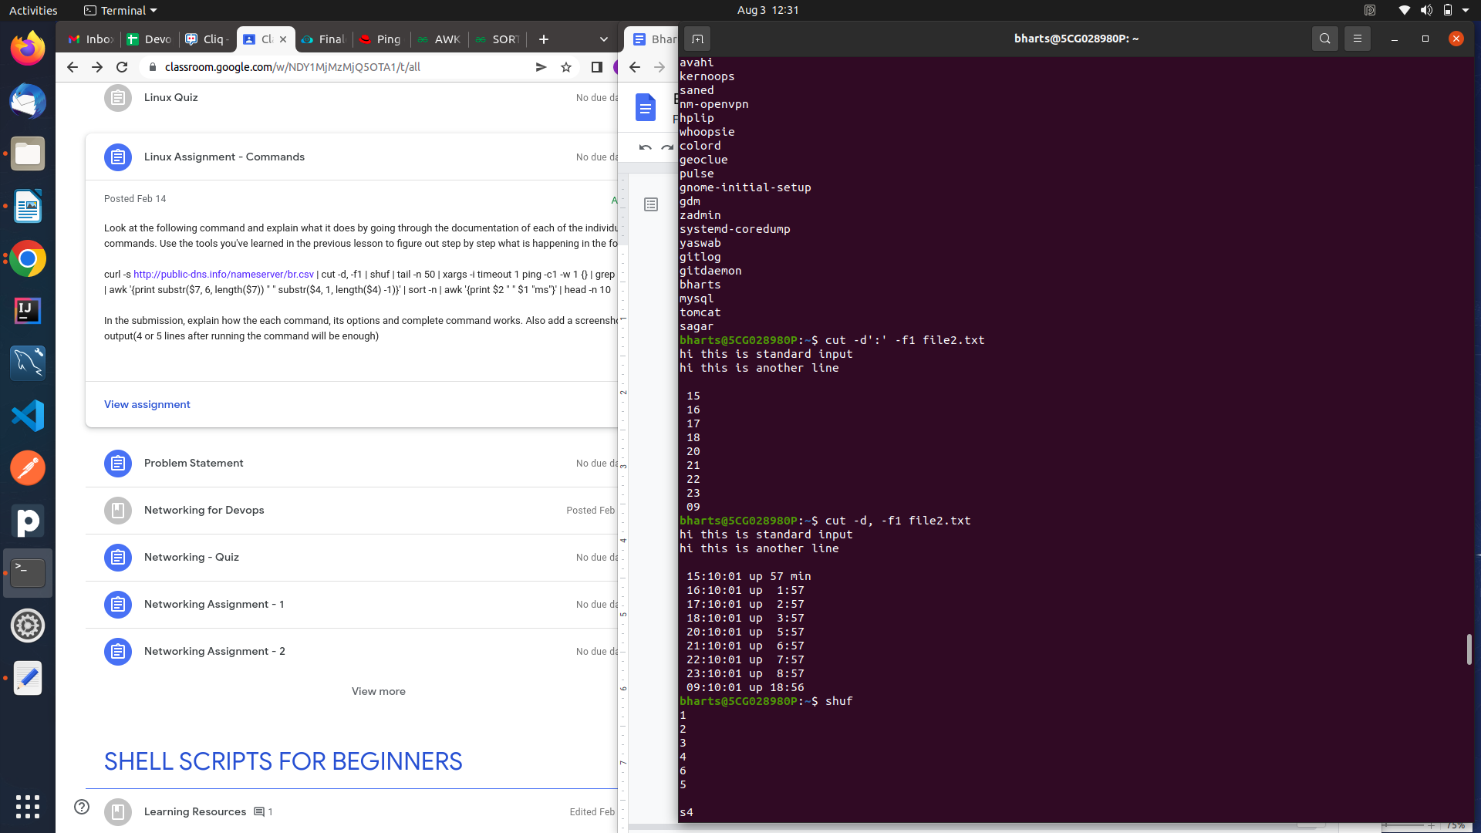

**Shuf** -writes a random permutation of the input lines to standard output.

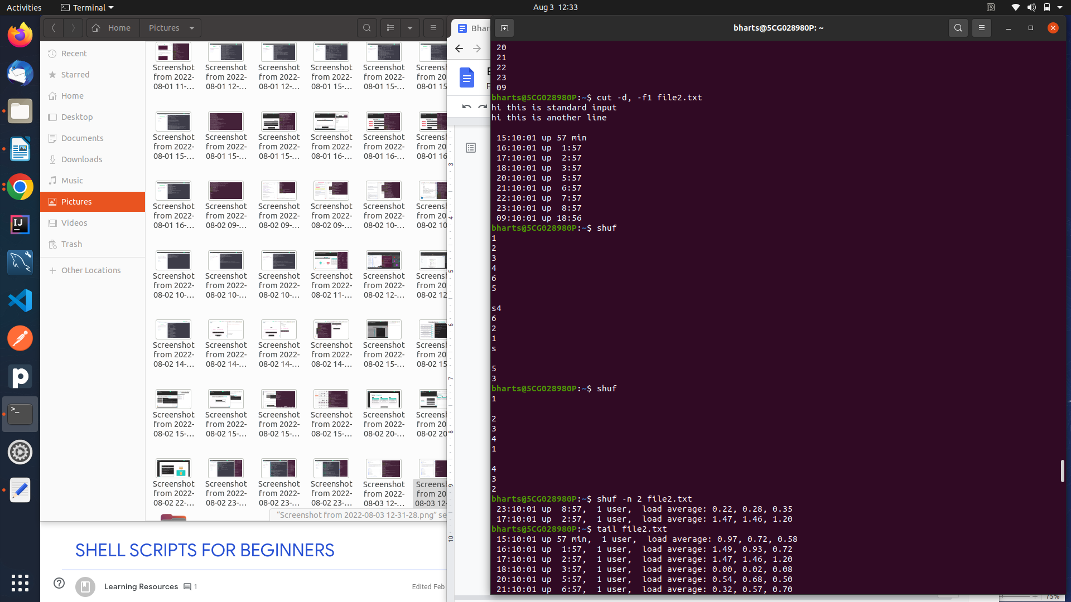

**Tail -n 50**-print the last N number of data of the given input. -n is for no of lines.

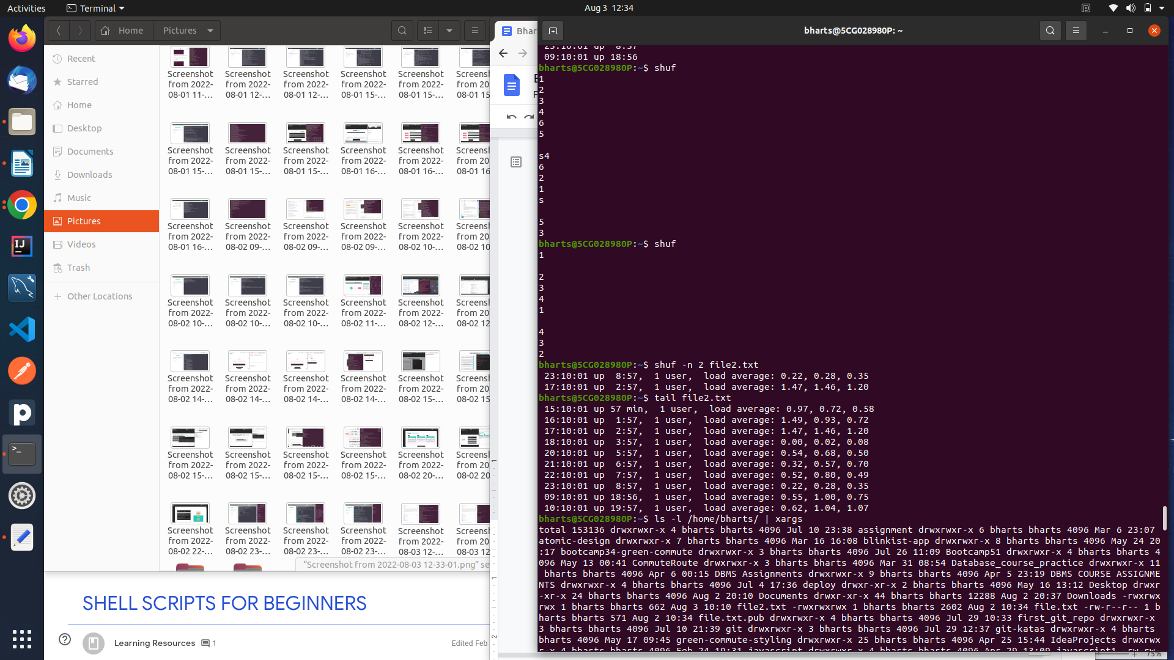

**xargs -i timeout 1 ping -c1 -w 1 {}** -

xargs is used to print the output into single line and it accepts piped input,

use multiple commands with xargs by using -i,

timeout 1 -timeout after 1 second,

Ping -c1 -w 1 - w is for timeout , -c 1 for no of pings,

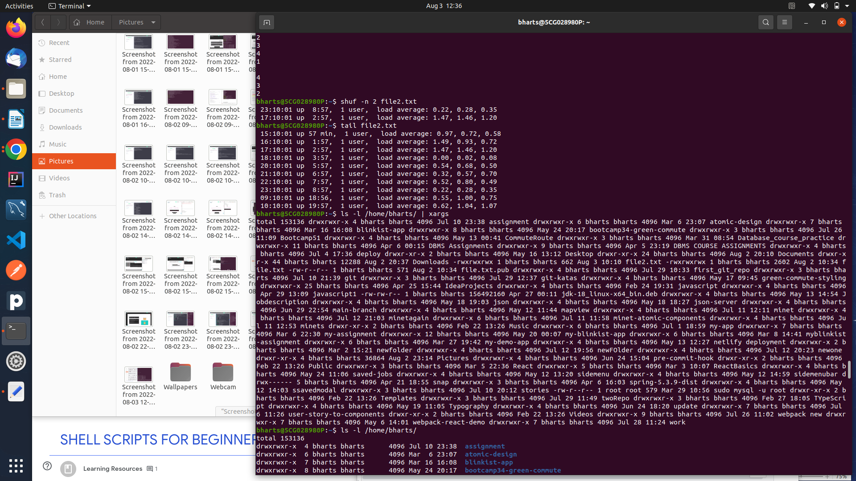

**Grep “time=”** - search “time=” in each line and return the lines.

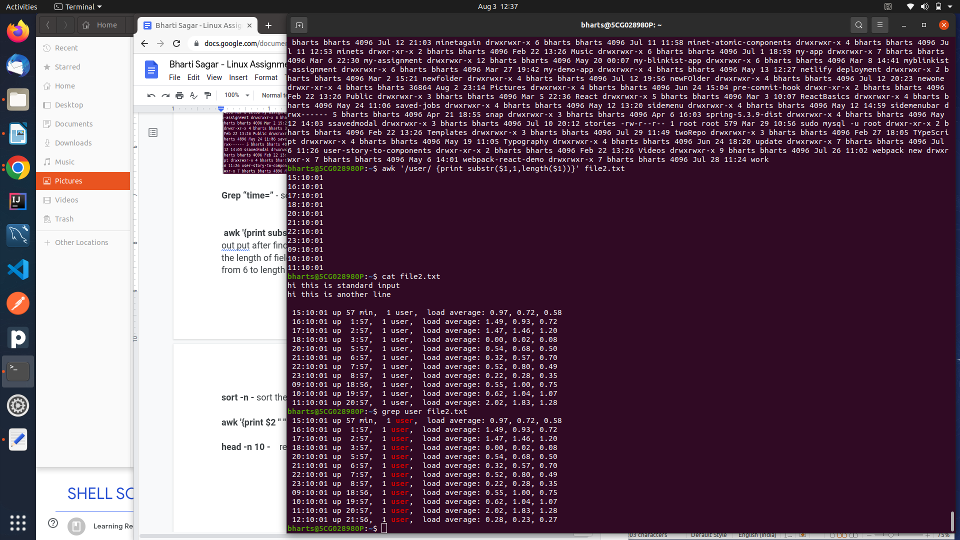

**awk '{print substr($7, 6, length($7)) " " substr($4, 1, length($4) -1)}'** - print the out put after finding the substring. $ is used for filed numbers, length is to find the length of fields,  **substr($7, 6, length($7))** it will return substring of field $7 from 6 to length of 7th field.

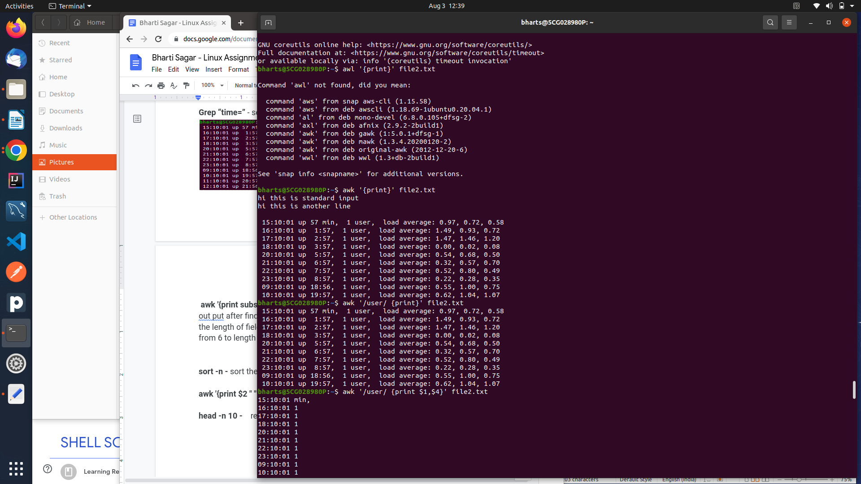

**sort -n -** sort the file according to numeric data

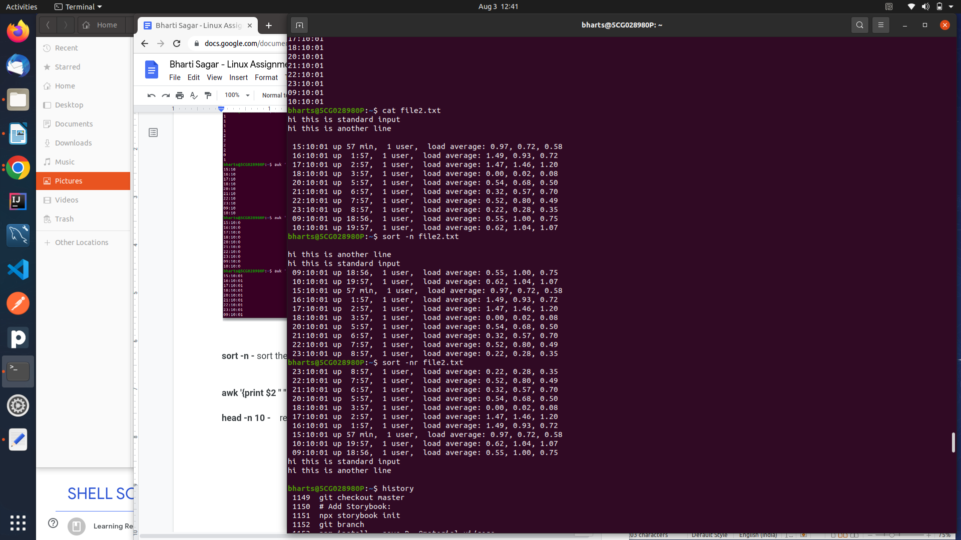

**awk '{print $2 " " $1 "ms"}' -** print $1 and $2 fields.

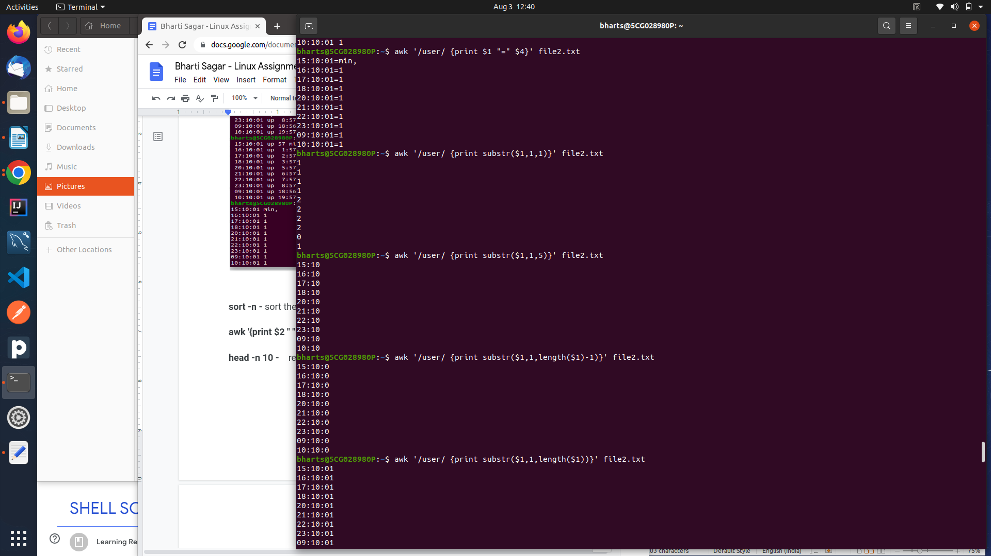

**head -n 10 -** return top 10 values**.**

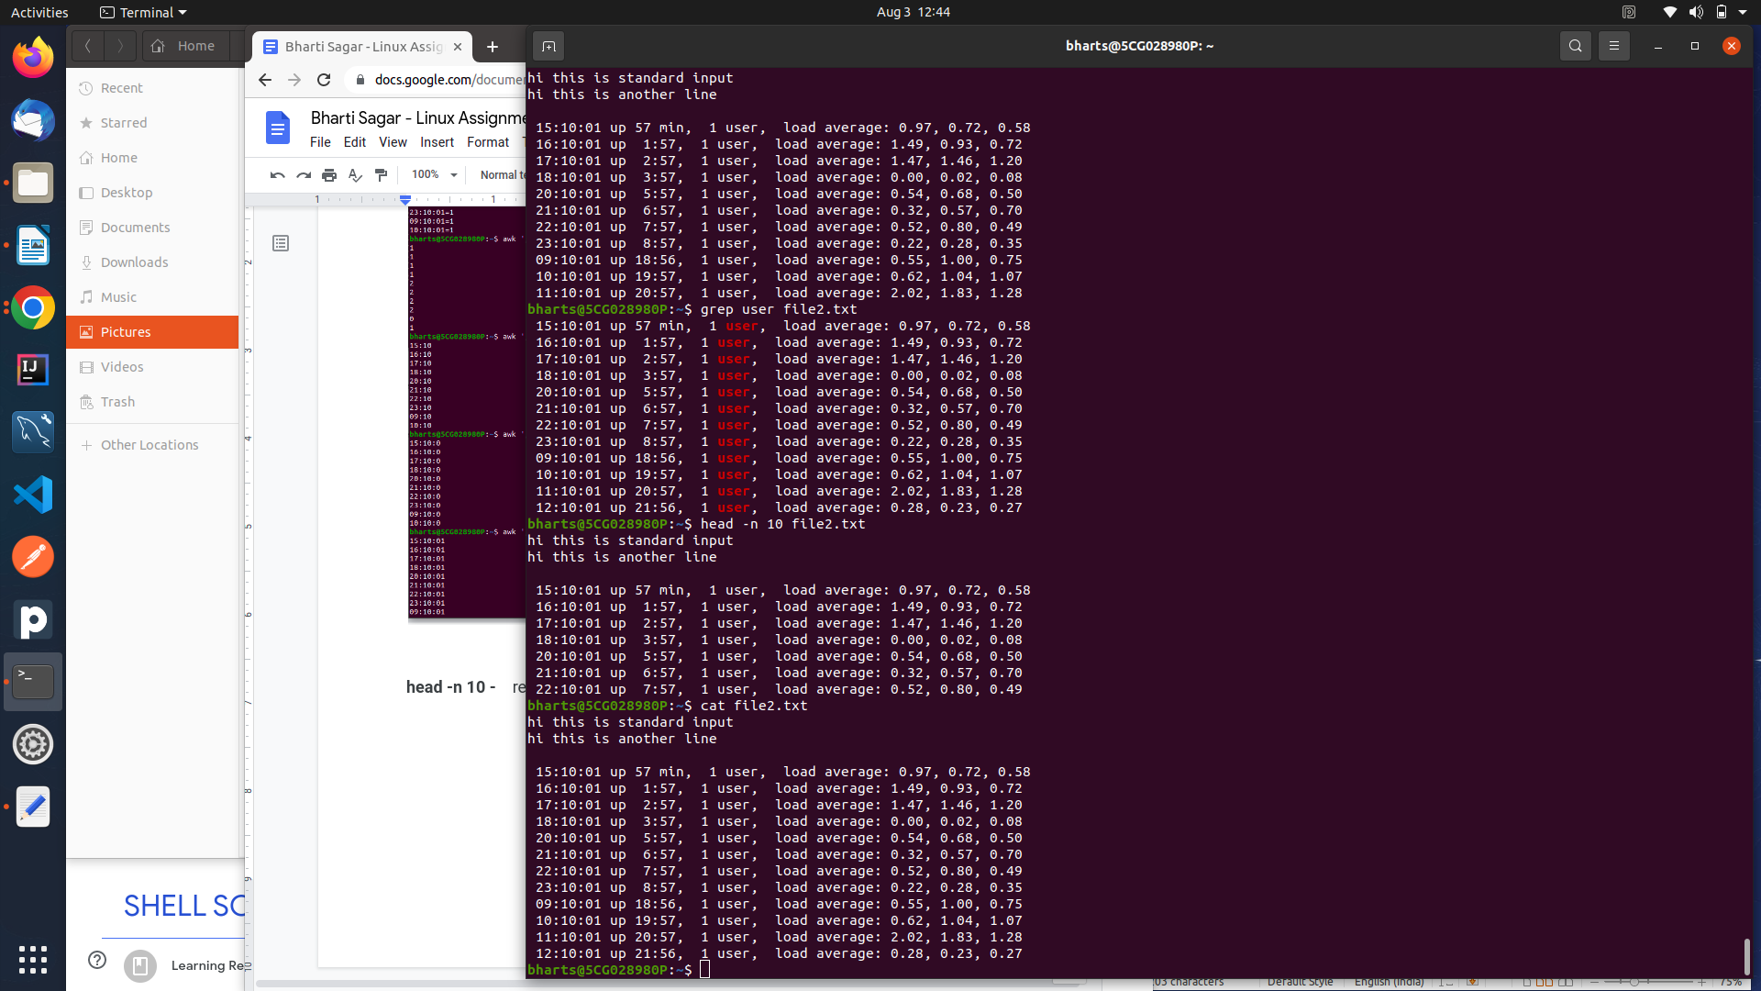

**Question-**

**curl -s** [**http://public-dns.info/nameserver/br.csv**](http://public-dns.info/nameserver/br.csv) **| cut -d, -f1 | shuf | tail -n 50 | xargs -i timeout 1 ping -c1 -w 1 {} | grep "time=" | awk '{print substr($7, 6, length($7)) " " substr($4, 1, length($4) -1)}' | sort -n | awk '{print $2 " " $1 "ms"}' | head -n 10**

